|  |
| --- |
|  |
| **DESIGN PHASE**  Assignment 3 Lecturer -Dr. **Thair Al-Dala'in** |
| |  |  |  | | --- | --- | --- | | RASMAN SURENDER MUKESH KUMAR ID-11693040 | 5/23/21 | ITC508 Object Modelling | |

Table of Contents

Task 1 2-6

Task 2 6-12

Task 3 12-13

References 13

**DESIGN PHASE**

**Task 1**

-Package Diagram for IDINE.

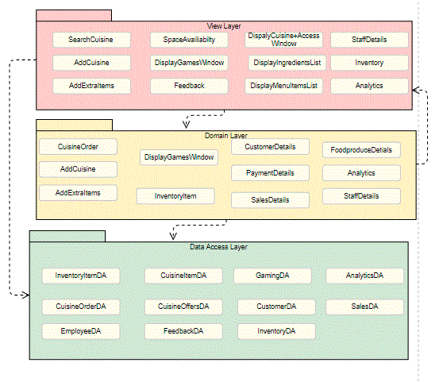

Fig 1. Package Diagram for IDINE system.

The three layers for the system are View layer, domain layer and data access layer.

View Layer : This layer displays the content to the user, which is dependent on domain and data access layer. Also the data is retrieved from these two layers.

* Search cuisine, Add cuisine and addextraitem elements are taken because it allows the user to search for own favourite dish, add additional cuisine and option to add extra snacks or beverages.
* Space availability: This element(table selection) shows the user is there is any available tables in the restaurant. User can choose the available ones and book in advance.
* Displaygames window: This element(play games) displays all the games on window screen. User can play them until there order arrives.   
  Benefits: Customers will be engaged and will not worry much about the order time
* Feedback: This element allows the customers to provide feedback after the payment and service.
* DisplayCuisine window and Display menu list: This element displays all the French cuisines menu to the customer. Customer can access the menu with rated cuisines, scroll down options and choose any of the cuisines.
* DisplayIngredientsList: This element display the ingredients of the selected cuisine and also its description. In this window customer can proceed to order if they like to have it. This window also shows ingredients with the amount of grams.
* Management:
* StaffDetails: This element displays each of the staff details like names, address, phone number, availability, photo, expertise, favourite cooking dish, education, incentives and feedback from customers.
* Inventory: This element displays the inventory stock details to the managers. This also include the food items, grocery items, utensils, vegetables, and other cooking items. In this Window managers can view available stock, out of stock items and can also make orders.
* Analytics: This element provides sales analytics, customer analytics, feedback analytics, inventory analytics to the manager.   
  Benefits: With Analytics managers can make proactive and strategic decision for increasing sales and improving customer experience.

Domain layer: In this layer the domain logic and restaurant business rules are defined. This layer is dependent on the data access layer for accessing the data to perform the domain logics.

* Payment details: This element includes the payment api, bank server links, and high level security encryption.
* Inventoryitems: This element includes the business rules, order rules and inventory items model for stock maintainance.
* CustomerDetails: This element includes the customer details, domain model for customer, its connection to the database and analytics.
* CuisineOrder, Add Cuisine and addextra items: This elements includes the rules for ordering, adding additional cuisine, adding extra items .
* FoodProduceDetails: This element includes the rules and domain model for food produce and its connection to stock, item descriptions, unit price, discounts and other related analytic services.
* Staff details and Analytics: This element includes the employee access rules, staff rules and its analytics.

Data Access layer: This layer includes the independent data storage, a database server and the other two layers with interact with this data access layer.

* InventoryItemDA: This element has the data for the inventory items, inventory stock and supplier details. This data is also used for supplier and inventory item analysis.
* CuisineOrderDA: This element stores the data when each customer orders a cuisine and related items. This can also be used for providing recommendations next time for similar customers.
* EmployeeDA: This element stores employee’s data and can be accessed by view layer and domain layer.
* FeedbackDA: This element includes all the data of customers feedback on service, food , environment, staff, etc.
* GamingDA: This element includes the storage of games data, and will be accessed by the domain layer and view layer. Customer and staff can access the game data. However, managers can later use the games played by customer to provide the similar cuisines ordered by other customers.
* CustomerDA: This element includes the storage of al the customers details like name, payment method, card used, table number, customers approximate age and other additional details. This data later will be used for customer analytics to improve sales and service.
* InventoryDA: This element has the data access for storage of inventory, out of stock items, available items , supplier details, and food produce details.
* AnalyticsDA: This element stores the charts, reports and analysis data for inventory, customers, staff and feedback.
* SalesDA: This element has the data access for the sales in the restaurant, special items, discounts and prices.

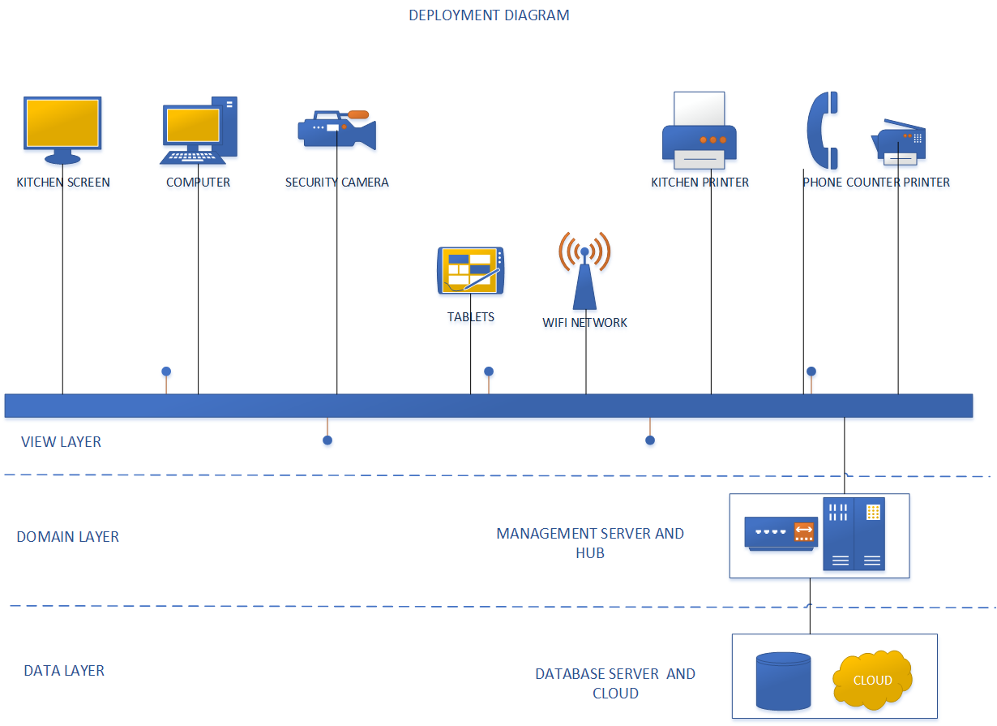

FIG 2: Deployment Diagram for IDINE System

Deployment Diagram: It’s a type of UML diagram which models the hardware and software components of an object oriented system.

* In Fig.2, the view layer includes the hardware components of the system which are dependent on the data access layer and domain layer components.   
  This is used for displaying the data/content to customers and restaurant management.
* The Domain layer includes the management server and the hub. This layer proves a medium for the transfer of data with business rules and domain logic to the view layer.  
  These components are used for network maintenance, connectivity and server data access.
* The Data Access layer includes the database server and cloud server. The components in this layer provides data access to the view layer components and domain layer components for effective functioning of the system.

OVERALL SYSTEM ARCHITECTURE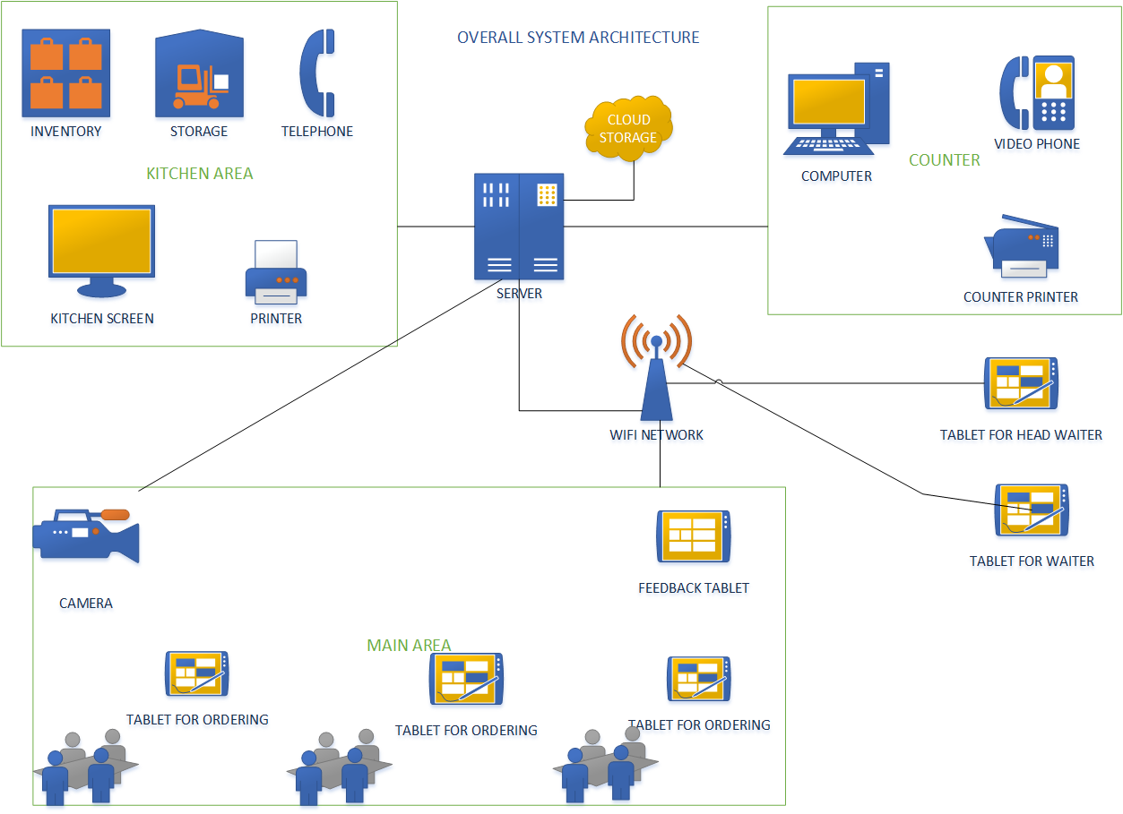

Fig 3. Overall Architecture of the IDINE restaurant system.

Fig 3. Shows the overall and high-level view of the system. There are three major areas which include kitchen area, main or dining area, and counter area.

-In the kitchen area, components related to inventory, visual display technologies , hardware components , software for the systems and communication technologies is included. The hardware components are connected to the management server and the wifi network.

-In the counter area, components related to hardware, restaurant management software for the system and beverages are included over the counter.

-In the Dining or main area, hardware and software components like tablets for ordering , tables, security cameras and a tablet for the feedback near the exit are included.

**Task 2**

**User Interface mock ups in storyboards procedure.  
Mock Up for Customer Ordering Use case**

****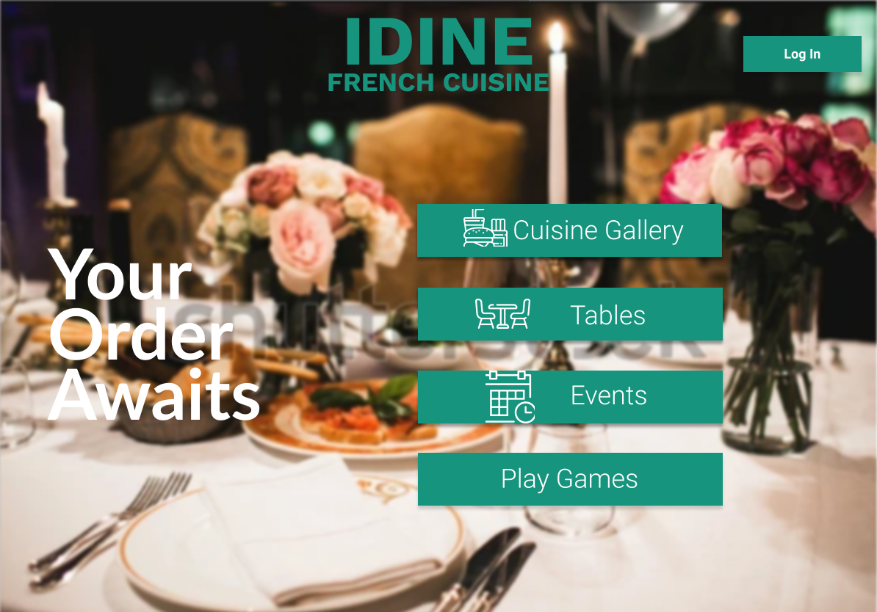

**1**User views the home menu and clicks on cuisine gallery for viewing french dishes at the IDINE

****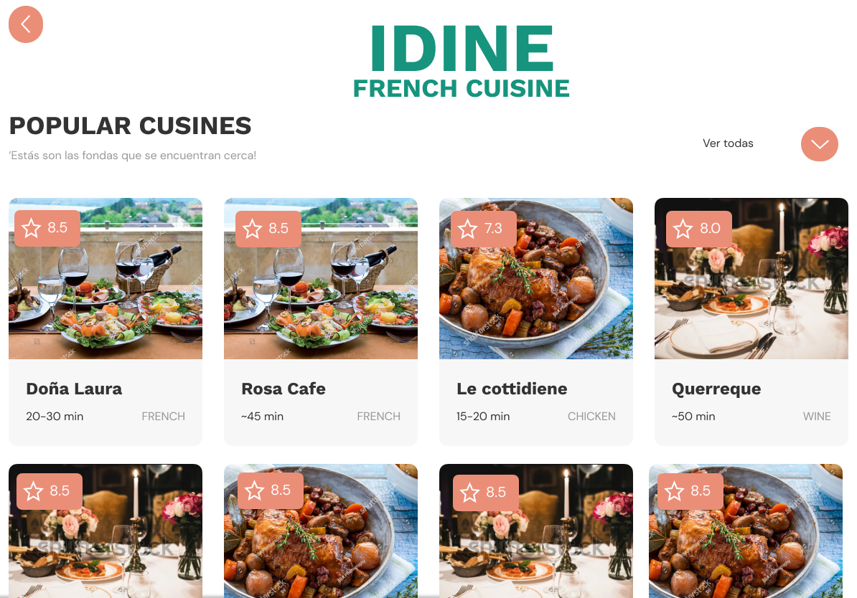

User clicks on the scroll down button to view more dish and choose one from the menu



**2**User selects the cuisine dish

****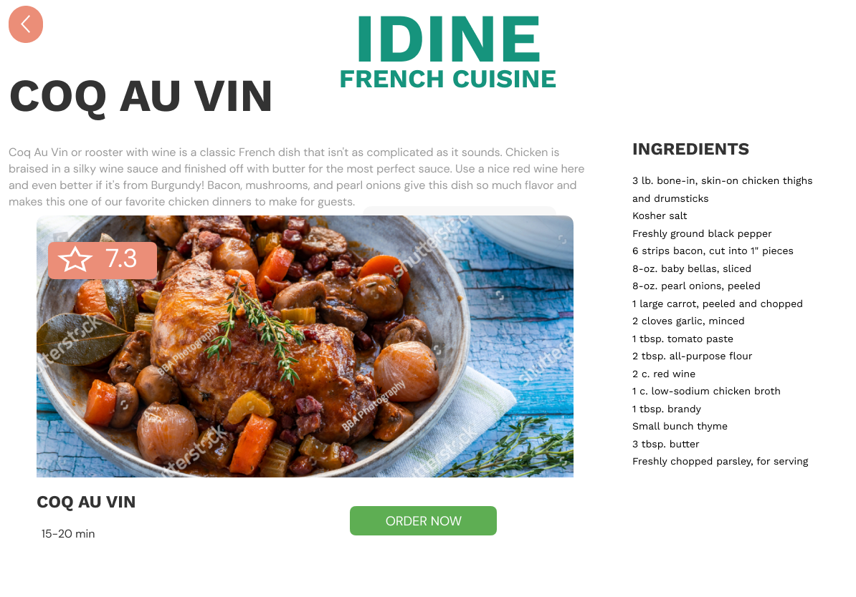 ****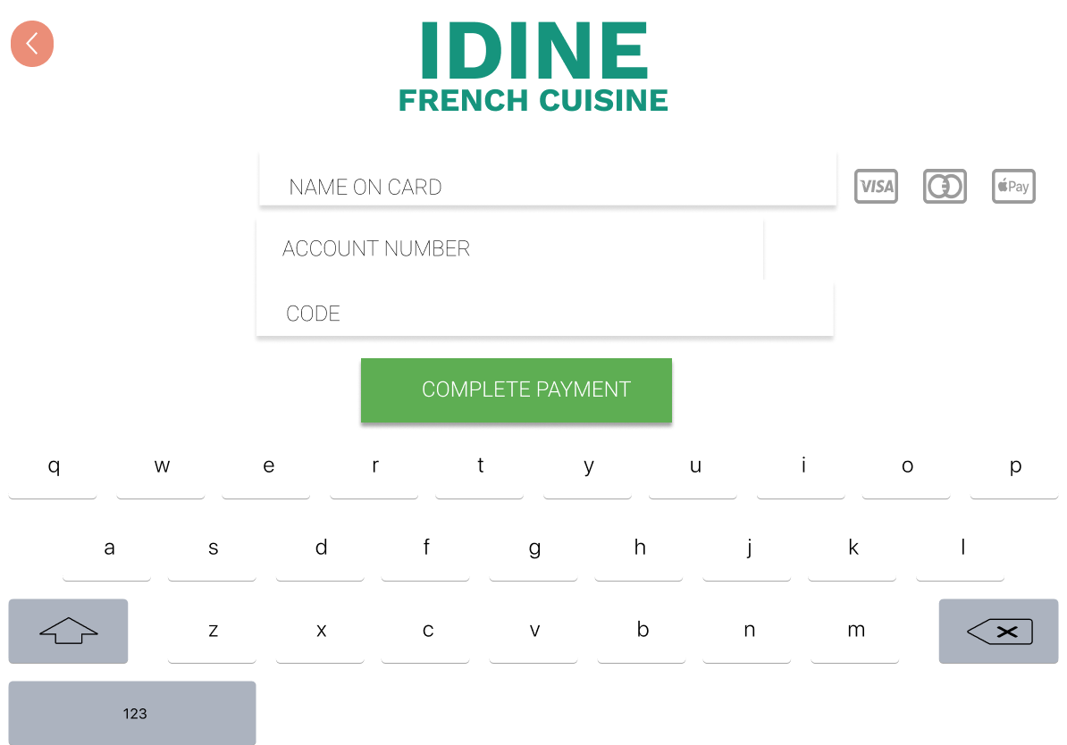

**3**User likes the dish and proceeds to order by clicking on order now

**4**User views the ingredients list

5User clicks on the complete payment to confirm the order and payment

6User enters the card details for making payment

****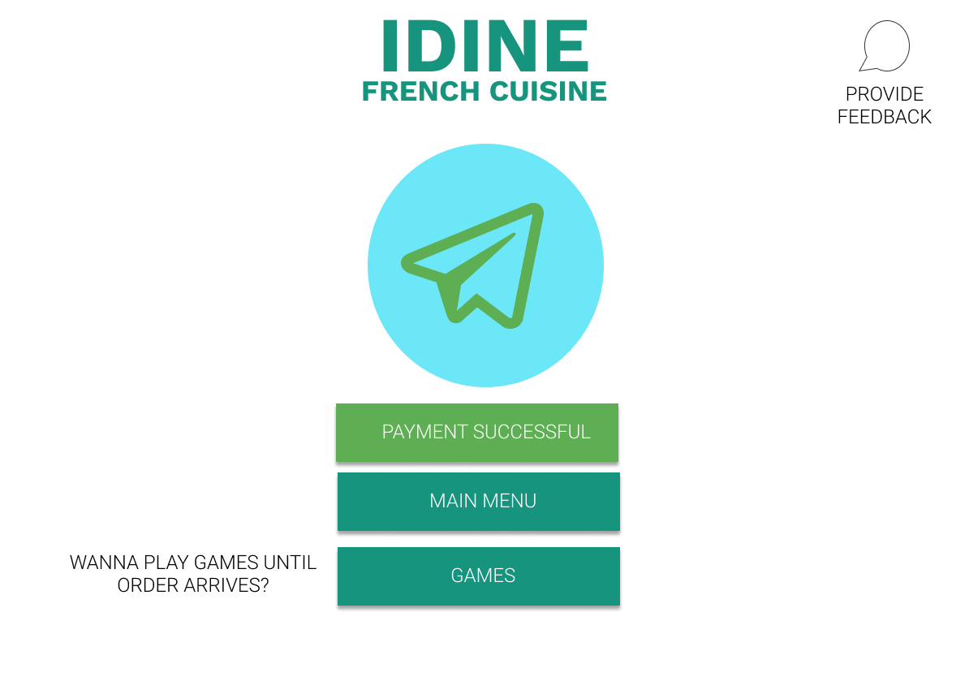

**7**User may provide the feedback now for the interaction, ease of use. Alternatively user can also provide feedback on the tablet at the exit door

**8**User clicks on this games button to view and play games until the order arrives.

USECASE 2 – Exit Door Feedback system

****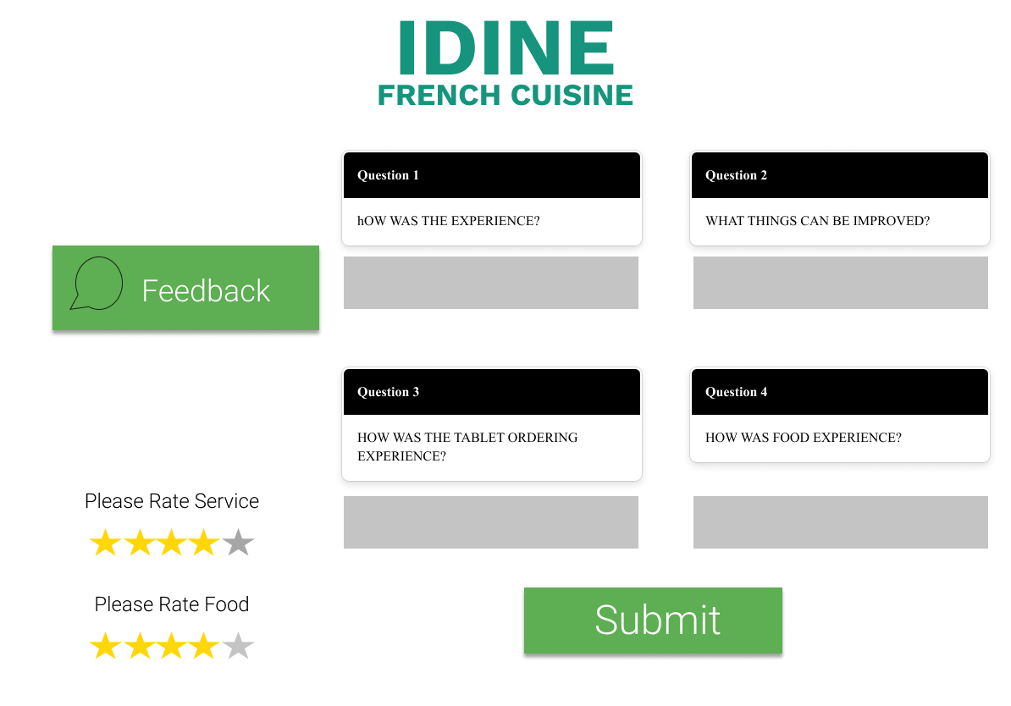

**9**after answering feedback questions and rating, user clicks on the submit button

10User rates the service and food quallity out of 5 stars.

**11**User clicks on the text box and Enters the text for the feedback question

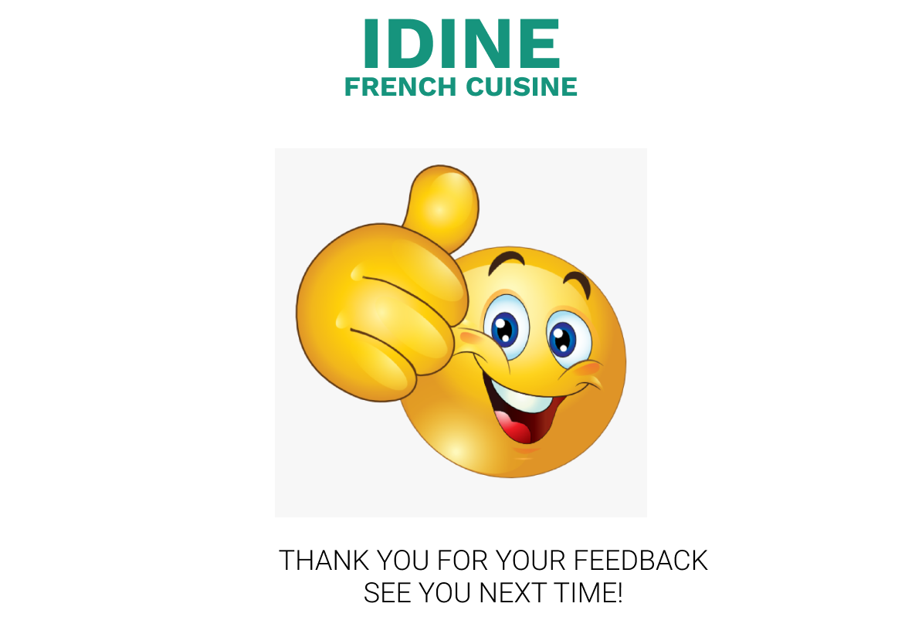

This storyboard acknowledges the customer with a Thank You note.

**Task 3**

**Drill-Down Report**- Drill down report defines the granularity in the data. It is a report to view extra details which are related to a product or item.

* From the case study we have selected the customer order and item details. A manager can view order details of customer like name, table number, payment approval.
* When the manager clicks on the order id of any row it displays another indent detail like item name, price, quantity, discount and total amount for that order.
* Again, when the manager clicks on the item name, they can see the item information like its supplier, quantity, unit price, inventory quantity and another tabular data related to item supplier.



|  |  |  |  |  |
| --- | --- | --- | --- | --- |
| Order ID | Order Date | Customer Name | Table number | Payment Done |
| 01234 | 22/05/2021 | John Mark | 3 | Yes |
| 56789 | 20/05/2021 | Sam lane | 5 | No |
| 91011 | 23/05/2021 | Mike albert | 1 | Yes |

**12**Clicking on the order ID of first row

|  |  |  |  |  |  |
| --- | --- | --- | --- | --- | --- |
| Order ID | Item name | Unit price(UP) | Quantity | Discount | Total Amount |
| **Right pointing backhand index**01234 | French Dish with Chicken | 135$ | 1 | 0.20% | 105$ |
| Italian Wine 1L | 170$ | 2 | 0.35% | 190$ |
| Staters | 90$ | 1 | 0.25% | 65$ |

Product Information

|  |  |  |  |  |  |
| --- | --- | --- | --- | --- | --- |
| Item Name | Category | Supplier | Quantity | Unit_price | Inventory Quantity |
| Italian Wine 1L | Wine | Romeio | 20 boxes/carton | 140$ | 33 |
| Supplier Information | | | | | |
| Supplier name | Contact Person | Designation | Phone | City | Address |
| Romeio | Jack | Distributing Manager | 0410234567 | Sydney | #34 North Bondi,2026, NSW |

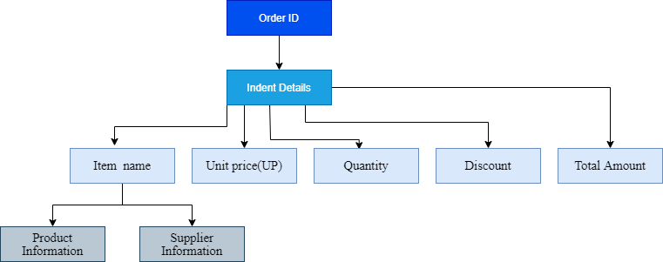

References:

Satzinger, J. W. (2016). *Systems analysis and design in a changing world* (Seventh edition.). CENGAGE Learning.

Cavusoglu, M. (2019). An analysis of technology applications in the restaurant industry. *Journal of Hospitality and Tourism Technology*, *10*(1), 45–72. <https://doi.org/10.1108/JHTT-12-2017-0141>

[Restaurant Analytics: Empower Your Business With Data & Software (datapine.com)](https://www.datapine.com/blog/benefit-from-your-data-with-restaurant-analytics/)

Bichler, B. F., Pikkemaat, B., & Peters, M. (2020). Exploring the role of service quality, atmosphere and food for revisits in restaurants by using a e-mystery guest approach. *Journal of Hospitality and Tourism Insights*, *ahead-of-print*(ahead-of-print). <https://doi.org/10.1108/JHTI-04-2020-0048>

Filimonau, V., & Krivcova, M. (2017). Restaurant menu design and more responsible consumer food choice: An exploratory study of managerial perceptions. *Journal of Cleaner Production*, *143*, 516–527. <https://doi.org/10.1016/j.jclepro.2016.12.080>

Wu, T.-H., Weng, S.-J., Lin, Y.-T., Kim, S.-H., & Gotcher, D. (2020). Investigating the importance and cognitive satisfaction attributes of service quality in restaurant business—A case study of TASTy steakhouse in Taiwan. *Journal of Foodservice Business Research*, *23*(4), 263–284. <https://doi.org/10.1080/15378020.2020.1749799>